Desire transformed at Samson
By Cate McQuaid
GLOBE CORRESPONDENT APRIL 14, 2015
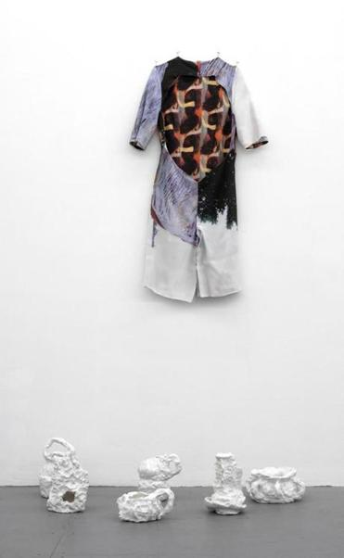
Feminists have decried the objectification of women for decades. Meanwhile, society is hooked on images like it is on sugar, and the objectification of women, and lately men, remains common currency. The CarWash Collective, a partnership between artist Beverly Semmes and fashion designer Jennifer Minniti, goes to the issue's core at Samson. Minniti designed prototypes for a collection using Semmes's "Feminist Responsibility Project" drawings as inspiration, and as patterns on her silk crepe de chine - drawings made on, and often redacting, pornographic imagery.
The nude has been transformed into the coverup. Yet, as in the drawings, there are peek-a-boo qualities, like the print revealed in the large cutout in the back of "Inside Out Beekeeper Dress." The porn is largely disguised, and here abstracted into patterns.
Where you can identify it, it's silly. In "Pillowcase Bomb Dress," a woman with dramatic eye makeup leans down, mouth open. Semmes colors over what's in her mouth with a cartoony pink circle rimmed in red, subverting any hint of seductiveness. The artists print the image in a grid pattern; that repetition also takes the teeth out of any eroticism.
They enlarge a fraction of the same drawing in "Bomb Study Cutout," a top with a bra shape snipped out. We see the bottom of the pink circle, and the woman's long fingers beneath. This top would reveal more than cleavage. The CarWash Collective astutely disarms porn, yet still plays a potent game of veiling and unveiling.
Semmes's ceramic works sit on the floor beneath the clothing, similarly laden with upended cultural signifiers. They're vessels, mostly, but not especially functional. Roughly hewn with crumples and protrusions, they look like undersea creatures. "Bright Bookends #4," does have utility, as Day-Glo yellow bookends. One has one handle, the other three, and seems to lean toward the first with hands on hips - a dynamic quietly echoed in the attitude the clothing embodies.
BEVERLY SEMMES & THE CARWASH COLLECTIVE: Body Double
At: Samson, 450 Harrison Ave., through April 25. 617-357-7177, www.samsonprojects.com

