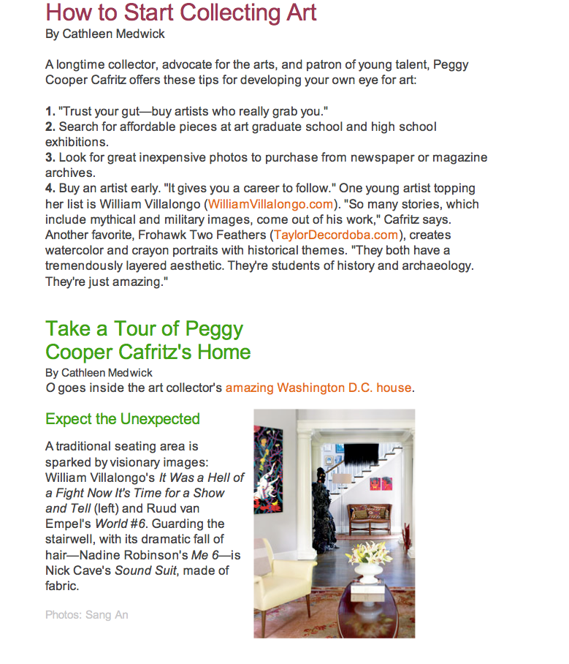
Wedwick, Cathleen, “How to Start Collecting Art,” O, July 2009.

